Palette Cards
Directions: Print out enough color versions of each card for each group or each student. Cut out the cards, fold, and glue the two sides together. Laminate the cards for extra durability.
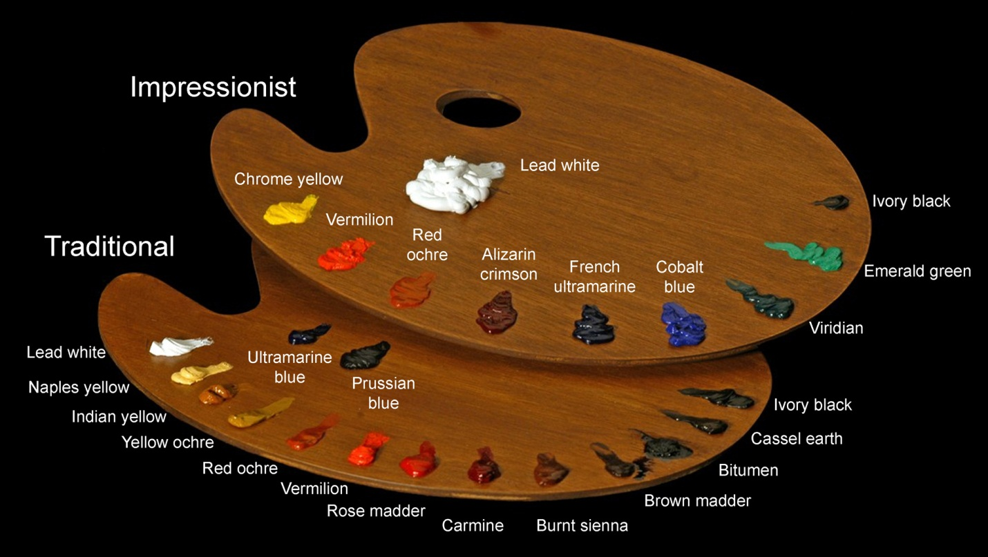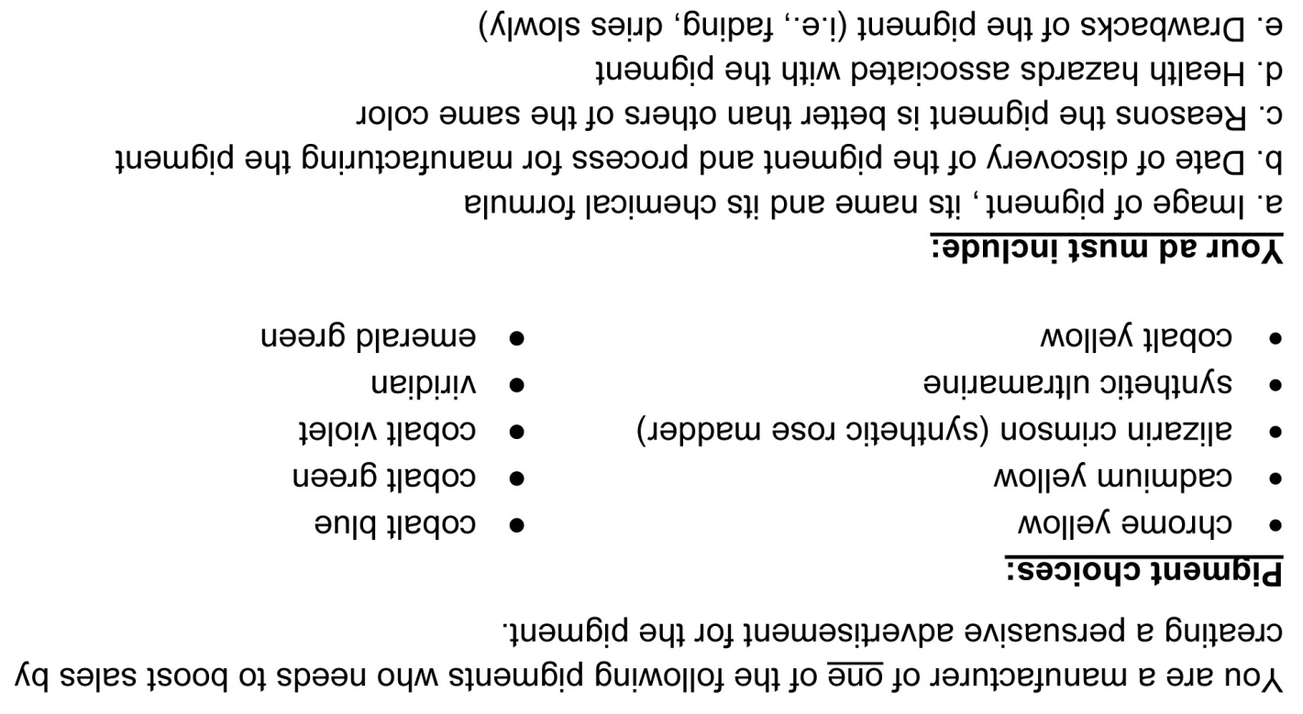
fold
fold
fold
fold

